2013 Optimal Settings
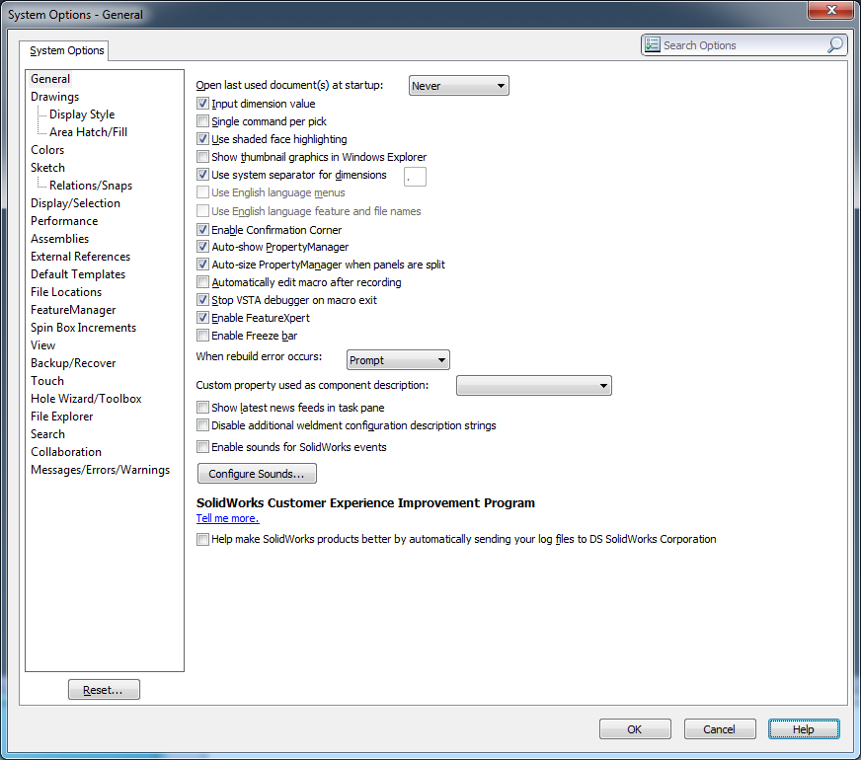
uncheck thumbnail
uncheck news feeds
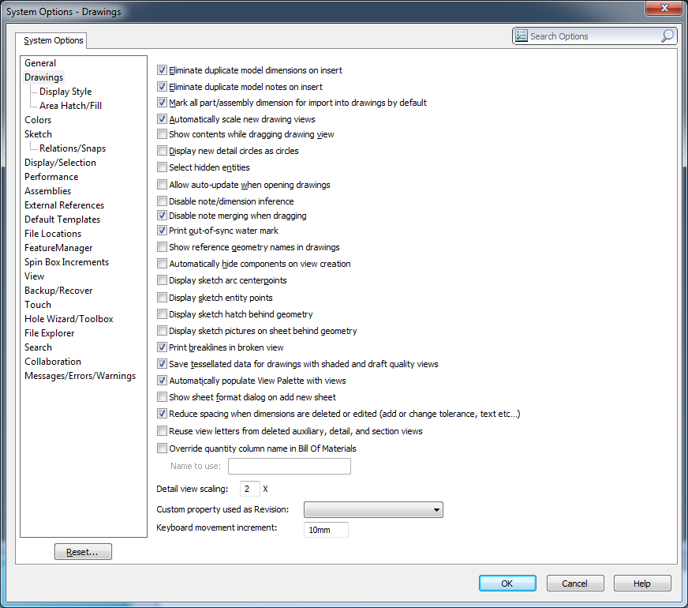
uncheck show contents while dragging
uncheck allow auto update when opening
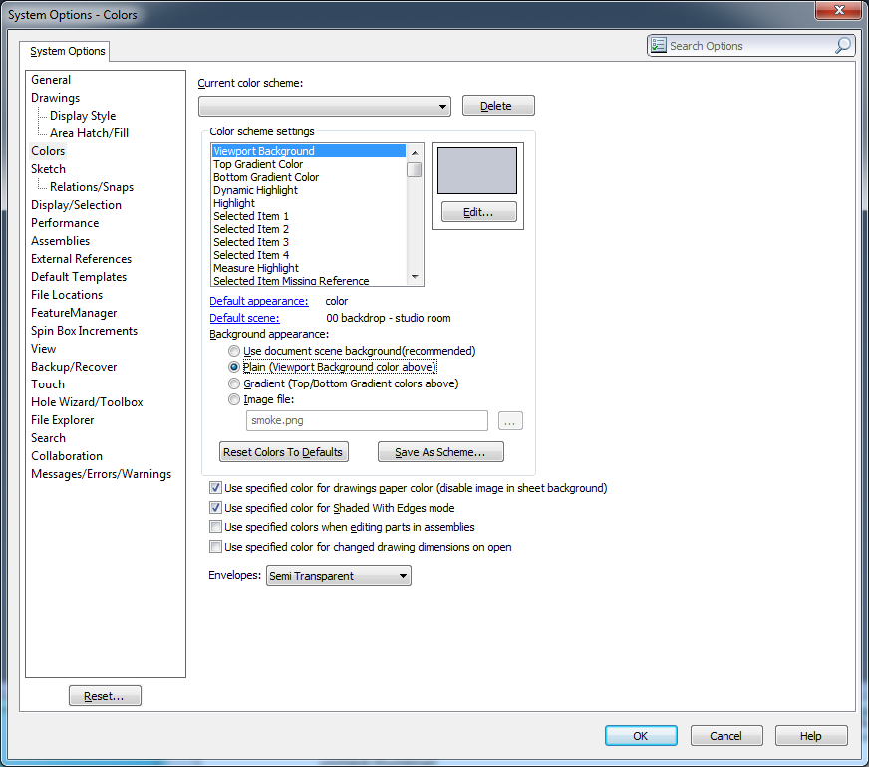
Set background to Plain
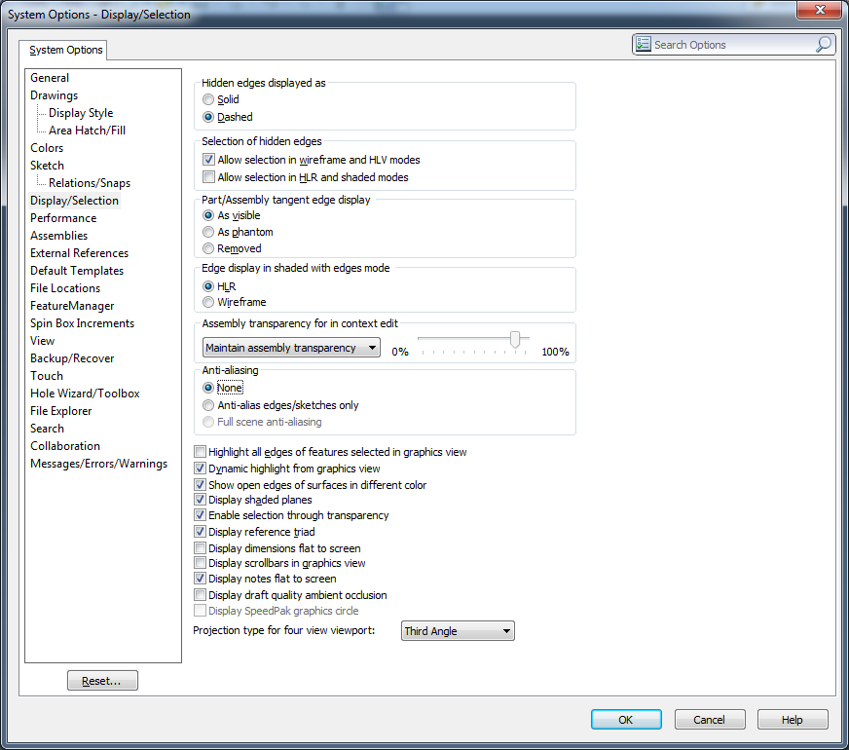
Maintain Assy Tran
Anti-aliasing set to None
Check Display draft quality ambient occlusion
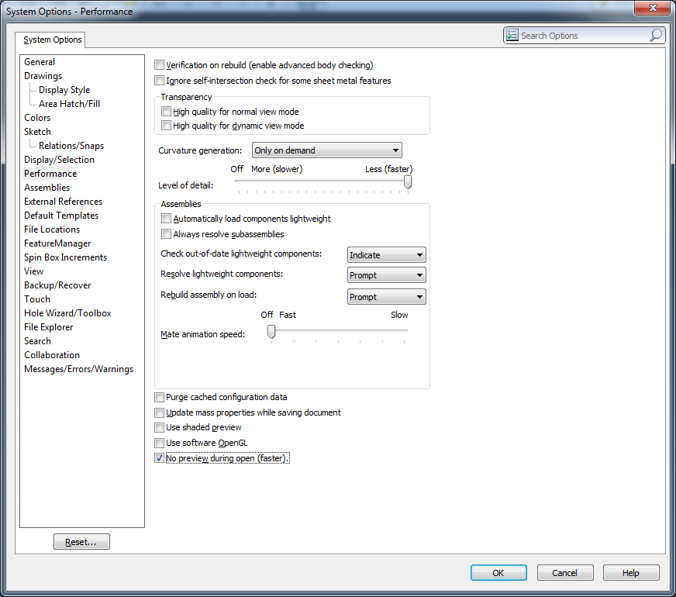
Uncheck Transparency options
Level of Detail to Less (Fast)
Auto load lightweight - Should be checked, but not for testing
Check out of date set to Indicate
Mate Animation set to Off
Uncheck Use shaded preview
Check No Preview
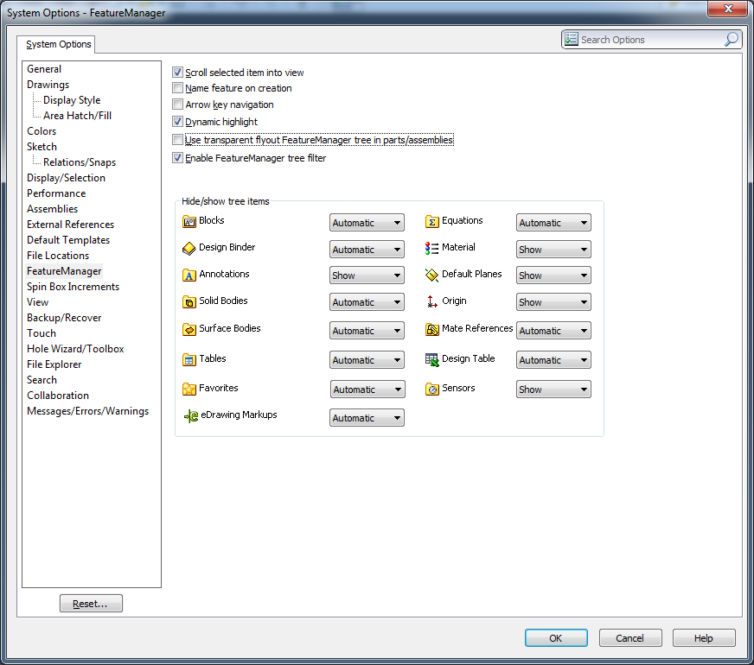
Uncheck Use Trans flyout FM
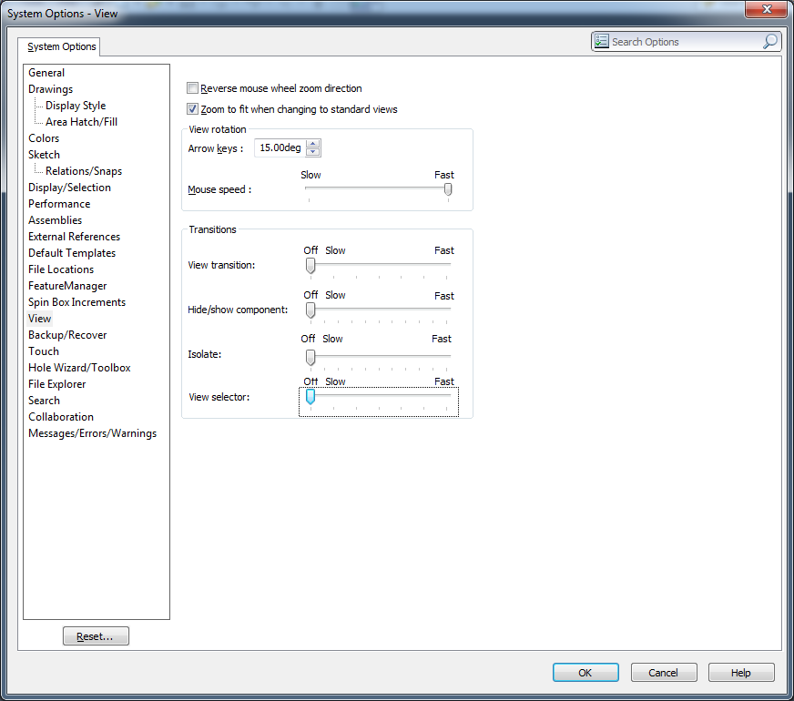
Zoom to fit should be unchecked but not practical
Set all Transitions to Off

