Visual Effects and Virtual Memory Change Instructions
To change the Visual Effects or Virtual Memory settings follow the instructions below to get to the Performance Options:
1. First go to Start and Right Click on Computer and select Properties.
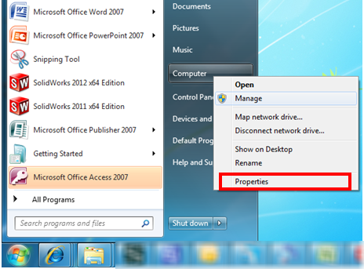
2. Next select Advanced system settings.
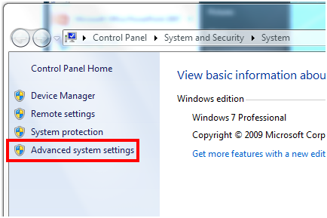
3. Next Select the Settings in the Performance area.
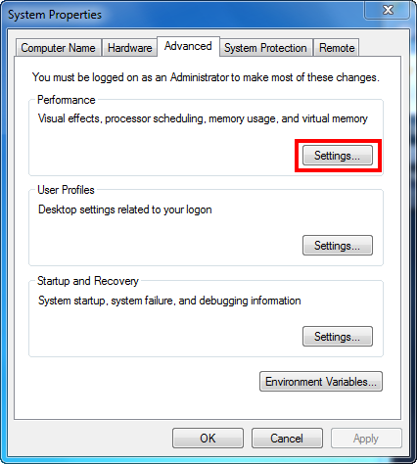
4a. Visual Effects: From the Visual Effects tab select the setting for Adjust for best performance to turn off all the Windows visual pretty settings.
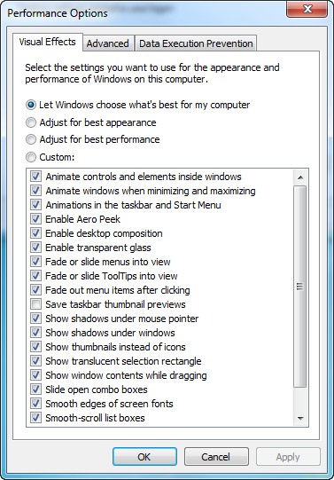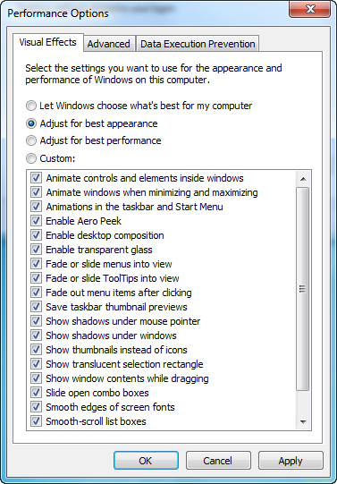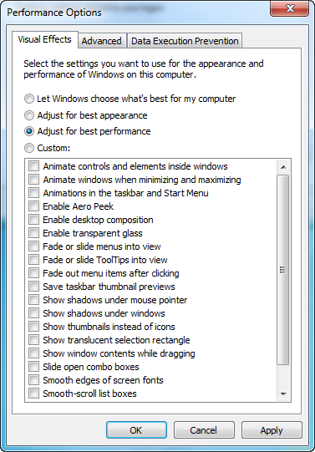
4b. Virtual Memory: From the Advanced tab in the Virtual memory area select Change.
In the Virtual Memory dialog box you want to set the Initial and Maximum sizes to be the same. The preferred setting is for 2x the amount of RAM in the machine.
